Free activities and ideas to learn about bats and churches
Learn about bats
Bats in Britain
Find out about the 18 species of bats found in Britain
Factsheet: https://cdn.bats.org.uk/pdf/Resources/Welsh-EdPack/02-British-bats-Eng.pdf?mtime=20190225150447&focal=none
Teachers’ notes: https://cdn.bats.org.uk/pdf/Resources/Welsh-EdPack/Teachers-Notes-2-British-Bats.pdf?mtime=20190225151035&focal=none
Source: Bat Conservation Trust
What do bats need to survive?
Factsheet: https://cdn.bats.org.uk/pdf/Resources/Welsh-EdPack/06-what-do-bats-need-Eng.pdf?mtime=20190225150615&focal=none
Teachers’ notes: https://cdn.bats.org.uk/pdf/Resources/Welsh-EdPack/Teachers-Notes-6-What-do-bats-need.pdf?mtime=20190225151217&focal=none
Source: Bat Conservation Trust
Why do we need bats?
Factsheet: https://cdn.bats.org.uk/pdf/Resources/Welsh-EdPack/07-people-need-bats-Eng.pdf?mtime=20190225150618&focal=none
Teachers’ notes: https://cdn.bats.org.uk/pdf/Resources/Welsh-EdPack/Teachers-Notes-7-People-need-bats.pdf?mtime=20190225151229&focal=none
Source: Bat Conservation Trust
Nature conservation and protection
Factsheet: https://cdn.bats.org.uk/pdf/Resources/Welsh-EdPack/09-Conservation-Strategies-Eng.pdf?mtime=20190225150634&focal=none
Teachers’ notes: https://cdn.bats.org.uk/pdf/Resources/Welsh-EdPack/Teachers-Notes-9-Nature-and-Conservation-strategies.pdf?mtime=20190225151251&focal=none
Source: Bat Conservation Trust

What are bats like?
https://cdn.bats.org.uk/pdf/Resources/B.6.e_-_Bats_are_like.pdf?mtime=20181101151535&focal=none
Source: Bat Conservation Trust
What do you know about bats? Take the quiz
https://cdn.bats.org.uk/pdf/Resources/True_or_false.pdf?mtime=20181101151554&focal=none
Source: Bat Conservation Trust
Myth-busting
https://www.nationaltrust.org.uk/features/five-myth-busting-bat-facts
Source: The National Trust
Bats in churches
https://www.bats.org.uk/our-work/buildings-planning-and-development/bats-and-churches/how-do-bats-use-churches
Source: Bat Conservation Trust
Practical
Put up a bat box
https://cdn.bats.org.uk/pdf/Our%20Work/Bat-Box-Information-Pack-May-2018.pdf?mtime=20181101151335&focal=none
Source: Bat Conservation Trust
Make your own bat box
https://www.wildlifetrusts.org/actions/how-build-bat-box
Source: The Wildlife Trusts
Learn about bat detectors
https://www.bats.org.uk/about-bats/bat-detectors-1
Source: Bat Conservation Trust
Surveying and monitoring for bats
Factsheet: https://cdn.bats.org.uk/pdf/Resources/Welsh-EdPack/08-Surveying-and-Monitoring-Eng.pdf?mtime=20190225150632&focal=none
Teachers’ notes: https://cdn.bats.org.uk/pdf/Resources/Welsh-EdPack/Teachers-Notes-8-Surveying-and-monitoring.pdf?mtime=20190225151240&focal=none
Source: Bat Conservation Trust
Bat walks
https://cdn.bats.org.uk/pdf/Resources/Bat_Walks.pdf?mtime=20181101151539&focal=none
Source: Bat Conservation Trust
Make a night garden
Stars of the night: https://cdn.bats.org.uk/pdf/Resources/Stars_of_the_Night.pdf?mtime=20181101151554&focal=none
Source: Bat Conservation Trust
Attracting bats and moths to your garden
https://www.wildlifetrusts.org/actions/how-attract-moths-and-bats-your-garden
Source: The Wildlife Trusts
Explore church yards
https://www.caringforgodsacre.org.uk/resources/education-pack/
Source: Caring for God’s Acre
Batty recipes
http://www.batcon.org/resources/media-education/learning/batty-recipes
Source: Bat Conservation International
Carve Halloween pumpkins (Jack o’lanterns in the USA)
http://www.batcon.org/resources/media-education/learning/jack-o-lantern
Source: Bat Conservation International

Literacy and art
Bat folk tales
http://www.bedsbatgroup.org.uk/wordpress/?page_id=574
Source: Bedfordshire Bat Group
Bats and culture
Factsheet: https://cdn.bats.org.uk/pdf/Resources/Welsh-EdPack/10-Culture-Eng.pdf?mtime=20190225151314&focal=none
Teachers’ notes: https://cdn.bats.org.uk/pdf/Resources/Welsh-EdPack/Teachers-Notes-10-Bats-and-culture.pdf?mtime=20190225151330&focal=none
Source: Bat Conservation Trust
How to draw a bat
https://cdn.bats.org.uk/pdf/Resources/How_to_draw_a_bat.pdf?mtime=20181101151550&focal=none
Source: Bat Conservation Trust
Crafty ideas
Make a bat hat
Have a competition, design your own or download a template
https://cdn.bats.org.uk/pdf/Resources/Bat_Hat_for_kids.pdf?mtime=20181101151538&focal=none
Source: Bat Conservation Trust
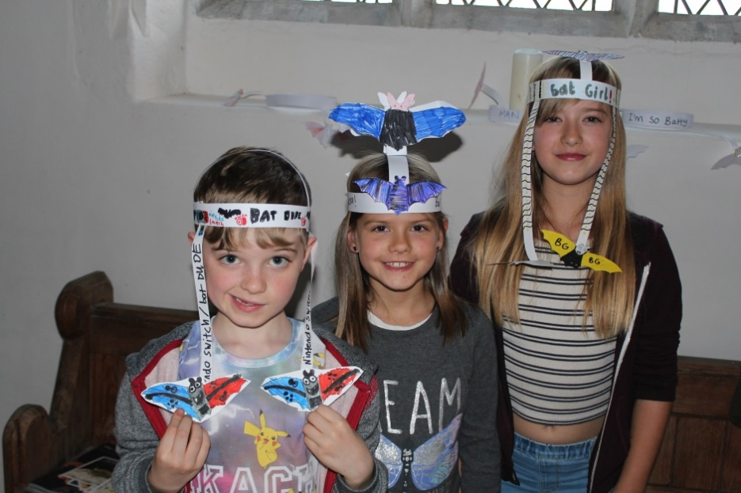

Children at All Saints Church, Wighton

Flapping bat
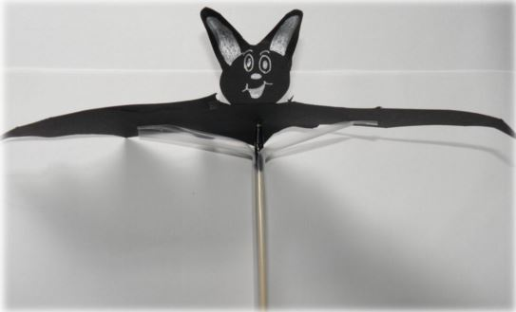
https://cdn.bats.org.uk/pdf/Resources/B.7.f_-_Flapping_bat.pdf?mtime=20181101151536&focal=none
Source: Bat Conservation Trust
Finger puppet
https://cdn.bats.org.uk/pdf/Resources/Finger_puppet_for_kids.pdf?mtime=20181101151549&focal=none
Source: Bat Conservation Trust
Bat costume
https://cdn.bats.org.uk/pdf/Resources/B.7.d_-_Bat_costume.pdf?mtime=20181101151536&focal=none
Source: Bat Conservation Trust
Bat masks
https://cdn.bats.org.uk/pdf/Resources/B.7.a_-_Bat_masks.pdf?mtime=20181101151535&focal=none
Source: Bat Conservation Trust
Origami bat
https://cdn.bats.org.uk/pdf/Resources/Origami_Bat.pdf?mtime=20181101151552&focal=none
Source: Bat Conservation Trust
Bat kite
https://cdn.bats.org.uk/pdf/Resources/Bat_Kite_2.pdf?mtime=20181101151538&focal=none
Source: Bat Conservation Trust
Needlefelt bat
https://cdn.bats.org.uk/pdf/Resources/Making_your_own_needle_felt_bat_1.pdf?mtime=20181101151551&focal=none
Source: Bat Conservation Trust
Science
Different adaptations between nocturnal and diurnal animals and birds
https://www.bbc.co.uk/bitesize/clips/z8mqxnb
Source: BBC Bitesize
What are bats? Classification and evolution
Fact sheet: https://cdn.bats.org.uk/pdf/Resources/Welsh-EdPack/Education-pack-01-What-are-bats-Eng.pdf?mtime=20190225150445&focal=none
Teachers’ notes: https://cdn.bats.org.uk/pdf/Resources/Welsh-EdPack/Teachers-Notes-1-What-are-Bats.pdf?mtime=20190225151015&focal=none
Source: Bat Conservation Trust
Bats’ life cycle
Factsheet: https://cdn.bats.org.uk/pdf/Resources/Welsh-EdPack/03-Bats-through-the-year-Eng.pdf?mtime=20190225150542&focal=none
Teachers’ notes: https://cdn.bats.org.uk/pdf/Resources/Welsh-EdPack/Teachers-Notes-3-Bats-through-the-year.pdf?mtime=20190225151101&focal=none
A year in the life of a bat: https://www.bats.org.uk/about-bats/a-year-in-the-life-of-a-bat
Source: Bat Conservation Trust
How do bats fly?
Factsheet: https://cdn.bats.org.uk/pdf/Resources/Welsh-EdPack/04-Flight-Eng.pdf?mtime=20190225150559&focal=none
Teachers’ notes: https://cdn.bats.org.uk/pdf/Resources/Welsh-EdPack/Teachers-Notes-4-Flight.pdf?mtime=20190225151129&focal=none
Work out your wingspan: https://cdn.bats.org.uk/pdf/Resources/Work-out-your-wingspan.pdf?mtime=20181101151556&focal=none
Source: Bat Conservation Trust
Seeing with sound
Factsheet: https://cdn.bats.org.uk/pdf/Resources/Welsh-EdPack/05-Echolocation-Eng.pdf?mtime=20190225150556&focal=none
Teachers’ notes: https://cdn.bats.org.uk/pdf/Resources/Welsh-EdPack/Teachers-Notes-5-Echolocation.pdf?mtime=20190225151147&focal=none
Source: Bat Conservation Trust
What is echolocation?
https://www.youtube.com/watch?v=K-zrBaIt-38
Source: BBC Earth Unplugged
Blind boy learning to echolocate
https://www.youtube.com/watch?v=zXtExOMCDfE
Source: BBC Earth
Church conservation, heritage and history
Teacher resources
https://www.visitchurches.org.uk/what-we-do/learning/schools.html
Source: Churches Conservation Trust
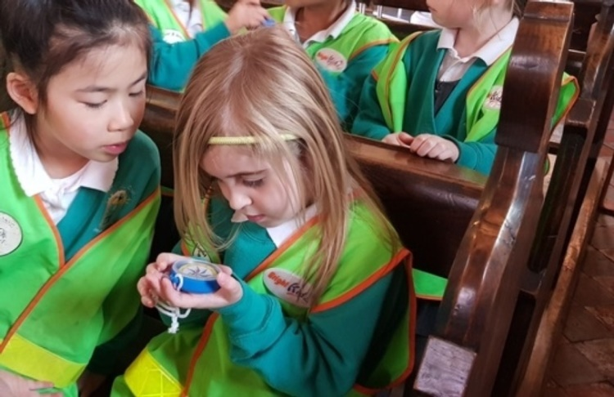
Inside a church
https://www.bbc.co.uk/teach/inside-the-church-what-do-you-need-to-know/zkkcnrd
Source: BBC Teach
Inspiring churches to explore
https://www.explorechurches.org/
Source: National Churches Trust

