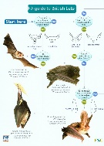
Supported By The National Lottery Heritage Fund

Suggested items for a bat walk kit for churches

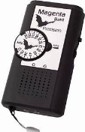
- NHBS beginner’s bat detecting kit comprises a basic detector (Magenta 4), FSC guide www.nhbs.com/a-guide-to-british-bats-book and batteries for £65.95: www.nhbs.com/beginners-bat-detecting-kit?bkfno=215869

- The next model up has a backlit LED screen showing frequency (Magenta 5). These are more expensive at £91.50 for the beginner’s kit: www.nhbs.com/beginners-bat-detecting-kit?bkfno=215869

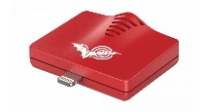
- In addition to the beginner’s kit you could invest in an Echo Meter Touch 2 which connects to smartphone or tablet (both iOS and Android) and shows the sonograms of the bat calls. This really adds interest to bat walks. There is an auto bat ID function but this is not 100% accurate. These devices are not essential, but they are very nice to have. The basic model is £199: www.nhbs.com/search?q=Echo+meter

- Although the detectors have small LED torches you might want a few more good torches and spare batteries for both the torches and the detectors.

- We recommend five beginner’s bat detecting kits at £65.95 each (Magenta 4, including FSC guide and batteries) = £329.75; adding an Echo Meter Touch would take the total to £528.75.

- If this is too expensive you could definitely hold a bat walk with just four detectors to reduce costs.

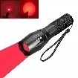
- Also nice to have, especially to see bats such as brown long eared that come out after dusk, is a red light LED torch, available at various online outlets.

- You can download a resource pack on how to run a bat event and lead a bat walk from http://bats_new.brix.fatbeehive.com/pages/batsforall.html

